SKILLS AND INTERESTS

I completed an online skills and interests inventory , **Holland Code** and **MyNextMove**. The results showed a strong inclination towards problem-solving, creativity, and analytical thinking.

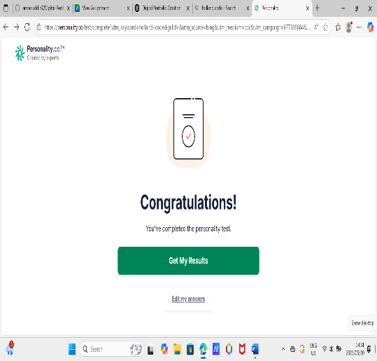

**STAR TECHNIQUE**

* **Situation:** I wanted to understand what skills and interests I naturally have in order to make informed career choices.
* **Task:** I needed to assess my aptitudes and preferences objectively.
* **Action:** I completed the Holland Code-based skills inventory online and reviewed the report.
* **Result:** I discovered that I have strong investigative and enterprising traits, which align well with careers in software engineering and entrepreneurship.